**CLOUD COMPUTING MINI PROJECT**

**WEBSITE WITHOUT SERVER**

**AIM:**

To create an efficient and cost-effective website without the need for traditional server infrastructure by leveraging cloud technologies. The primary objective is to design a serverless website that offers the same functionality and performance as a traditional server-based website while minimizing operational complexities and costs.

**ABSTRACT:**

Building a serverless website through cloud technologies represents a paradigm shift in web development, eliminating the need for dedicated server infrastructure. This project delves into the concept of serverless web development and its potential applications. We have designed and implemented a serverless website, harnessing the power of cloud services.

Creating websites without the constraints of traditional server setups opens up new opportunities for scalable, cost-efficient, and low-maintenance web solutions. In this project, we explore the development of a serverless website, showcasing its capabilities and benefits, which include reduced operational overhead and enhanced scalability.

**PROCEDURE:**

**Step 1:** Define Project Scope and Cloud Platform Selection

* Define the purpose of your serverless website, including user authentication and content navigation.
* Specify required features, such as login functionality and page navigation.
* Select a suitable cloud platform provider that offers serverless computing and hosting services, considering factors like ease of use and scalability.

**Step 2:** Plan Website Structure and Frontend Development

* Design the website's structure, including a homepage with login functionality and separate pages for About, Service, Industry, and Solution.
* Create the homepage with a login button using HTML, CSS, and JavaScript.
* Ensure the login button redirects users to the login page.

**Step 3**: Develop Login Page and Content Pages

* Design the login page to collect user input for email and password.
* Create a form for user authentication.
* Develop the content pages for About, Service, Industry, and Solution, and implement navigation to these pages from the homepage.

**Step 4:** Implement Backend Services and Authentication Logic

* Set up serverless functions for user authentication.
* Integrate backend services for email and password validation.
* Implement authentication logic to verify user input and handle user sessions and access control.

**Step 5:** Deployment, Testing, and Maintenance

* Deploy the website to the chosen cloud platform.
* Thoroughly test the website's functionality, including login and content navigation.
* Monitor and optimize the website for performance and cost-efficiency.
* Create documentation and provide training for your team to manage and maintain the website.
* Consider potential future enhancements, such as user registration or additional features.

**PROGRAM:**

<!DOCTYPE html>

<html lang="en">

<head>

<title>Webpage Design</title>

<link rel="stylesheet" href="style.css">

<link rel="stylesheet" href="https://cdnjs.cloudflare.com/ajax/libs/OwlCarousel2/2.3.4/assets/owl.carousel.min.css">

<script src="https://code.jquery.com/jquery-3.6.0.min.js"></script>

<script src="https://cdnjs.cloudflare.com/ajax/libs/OwlCarousel2/2.3.4/owl.carousel.min.js"></script>

<meta charset="UTF-8" />

</head>

<body>

<div class="main">

<div class="navbar">

<div class="icon">

<img src="cloud image transparent.png" alt="Hera Tech Logo" class="logo-img">

</div>

<div class="menu">

<ul>

<li><a href="index.html">HOME</a></li>

<li><a href="about.html">ABOUT</a></li>

<li><a href="service.html">SERVICE</a></li>

<li><a href="industry.html">INDUSTRY</a></li>

<li><a href="solution.html">SOLUTION</a></li>

</ul>

</div>

<div class="search">

<input class="srch" type="search" name="" placeholder="Type To text">

<a href="#"> <button class="btn">Search</button></a>

</div>

</div>

<div class="content">

<h1>Elevate Your World with <br><span>Cloud Computing</span> </h1>

<p class="par">Welcome to Cloud Computing, <br>where innovation knows no bounds. We specialize in cutting-edge technology solutions that empower businesses and individuals alike. Explore our products, services, and insights to embark on a journey of tech-driven transformation.</p>

<button class="cn"><a href="login.html">LOGIN IN</a></button>

</div>

</div>

</div>

</section>

<script src="https://unpkg.com/ionicons@5.4.0/dist/ionicons.js"></script>

<!-- Remove the container if you want to extend the Footer to full width. -->

<!DOCTYPE html>

<html>

<head>

<title>Web Tech Company</title>

<style>

/* Styling for the footer */

footer {

background-color: #333;

color: #fff;

padding: 20px;

text-align: center;

}

/* Styling for links in the footer */

footer a {

color: #fff;

text-decoration: none;

}

/* Styling for links on hover */

footer a:hover {

text-decoration: underline;

}

</style>

</head>

<body>

<!-- Your web page content goes here -->

<!-- Footer section -->

<footer>

<p>&copy; 2023 Cloud Computing</p>

<p>Contact us at <a href="mailto:info@webtechcompany.com">info@cloudcomputing.com</a></p>

</footer>

<!-- JavaScript code can be added here -->

</body>

</html>

<!--<div class="form">

<h2>Login Here</h2>

<input type="email" name="email" placeholder="Enter Email Here">

<input type="password" name="" placeholder="Enter Password Here">

<button class="btnn"><a href="#">Login</a></button>

<p class="link">Don't have an account<br>

<a href="#">Sign up </a> here</a></p>

<p class="liw">Log in with</p>

<div class="icons">

<a href="#"><ion-icon name="logo-facebook"></ion-icon></a>

<a href="#"><ion-icon name="logo-instagram"></ion-icon></a>

<a href="#"><ion-icon name="logo-twitter"></ion-icon></a>

<a href="#"><ion-icon name="logo-google"></ion-icon></a>

<a href="#"><ion-icon name="logo-skype"></ion-icon></a>

</div>

</div>

**OUTPUT:**

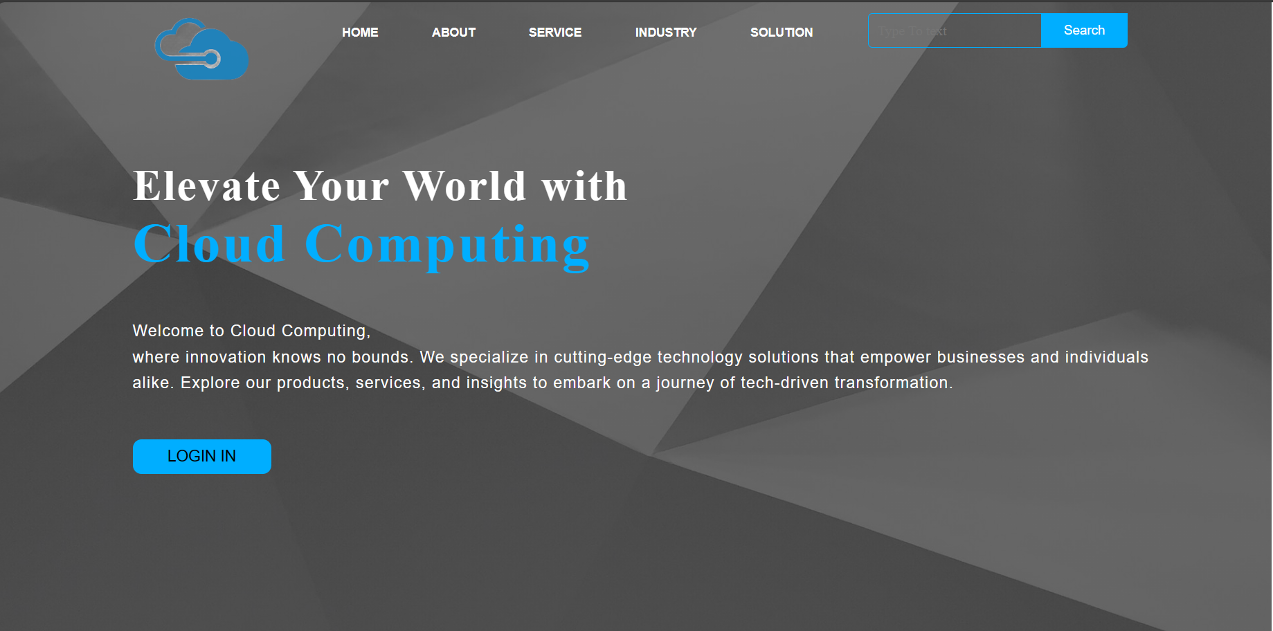

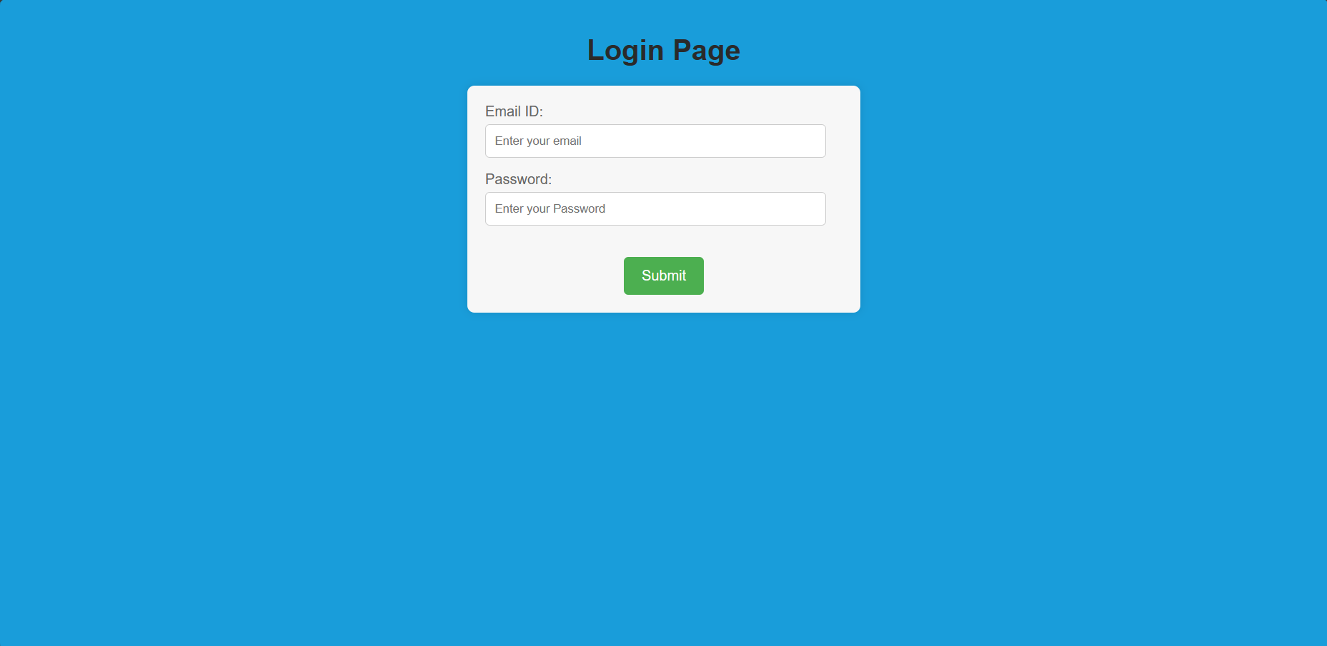

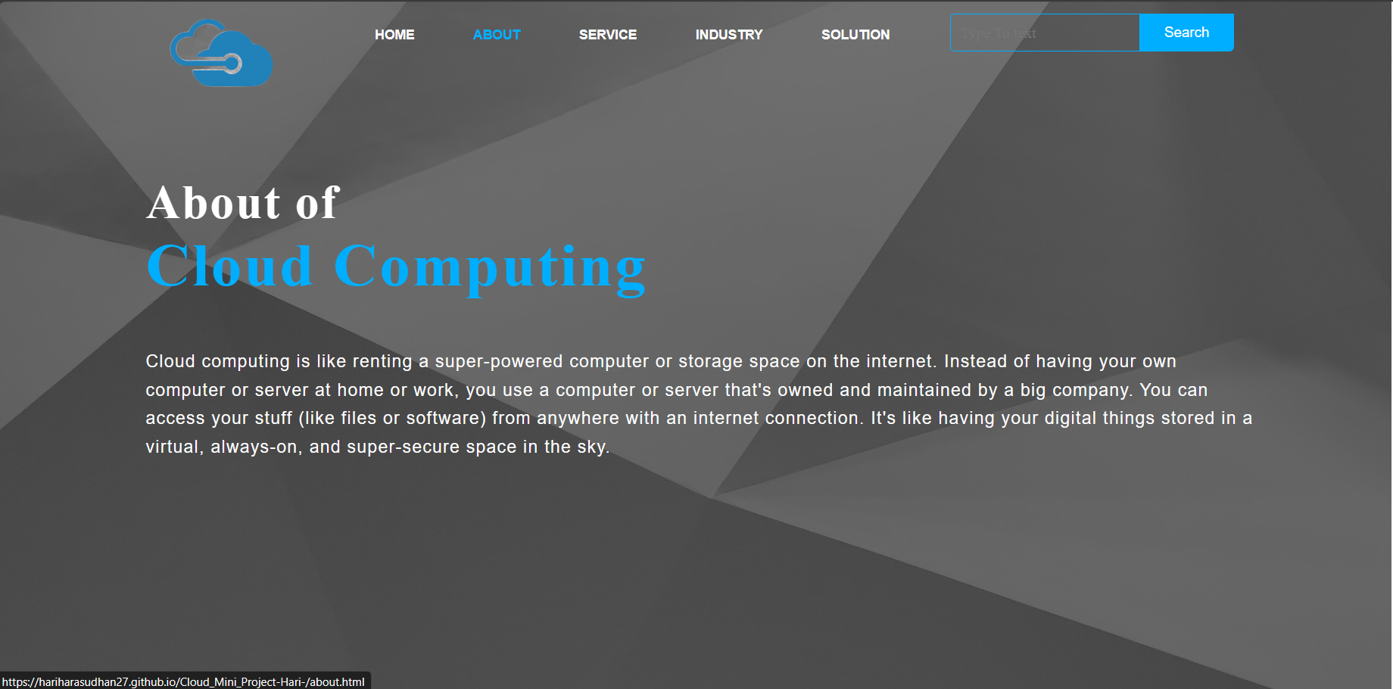

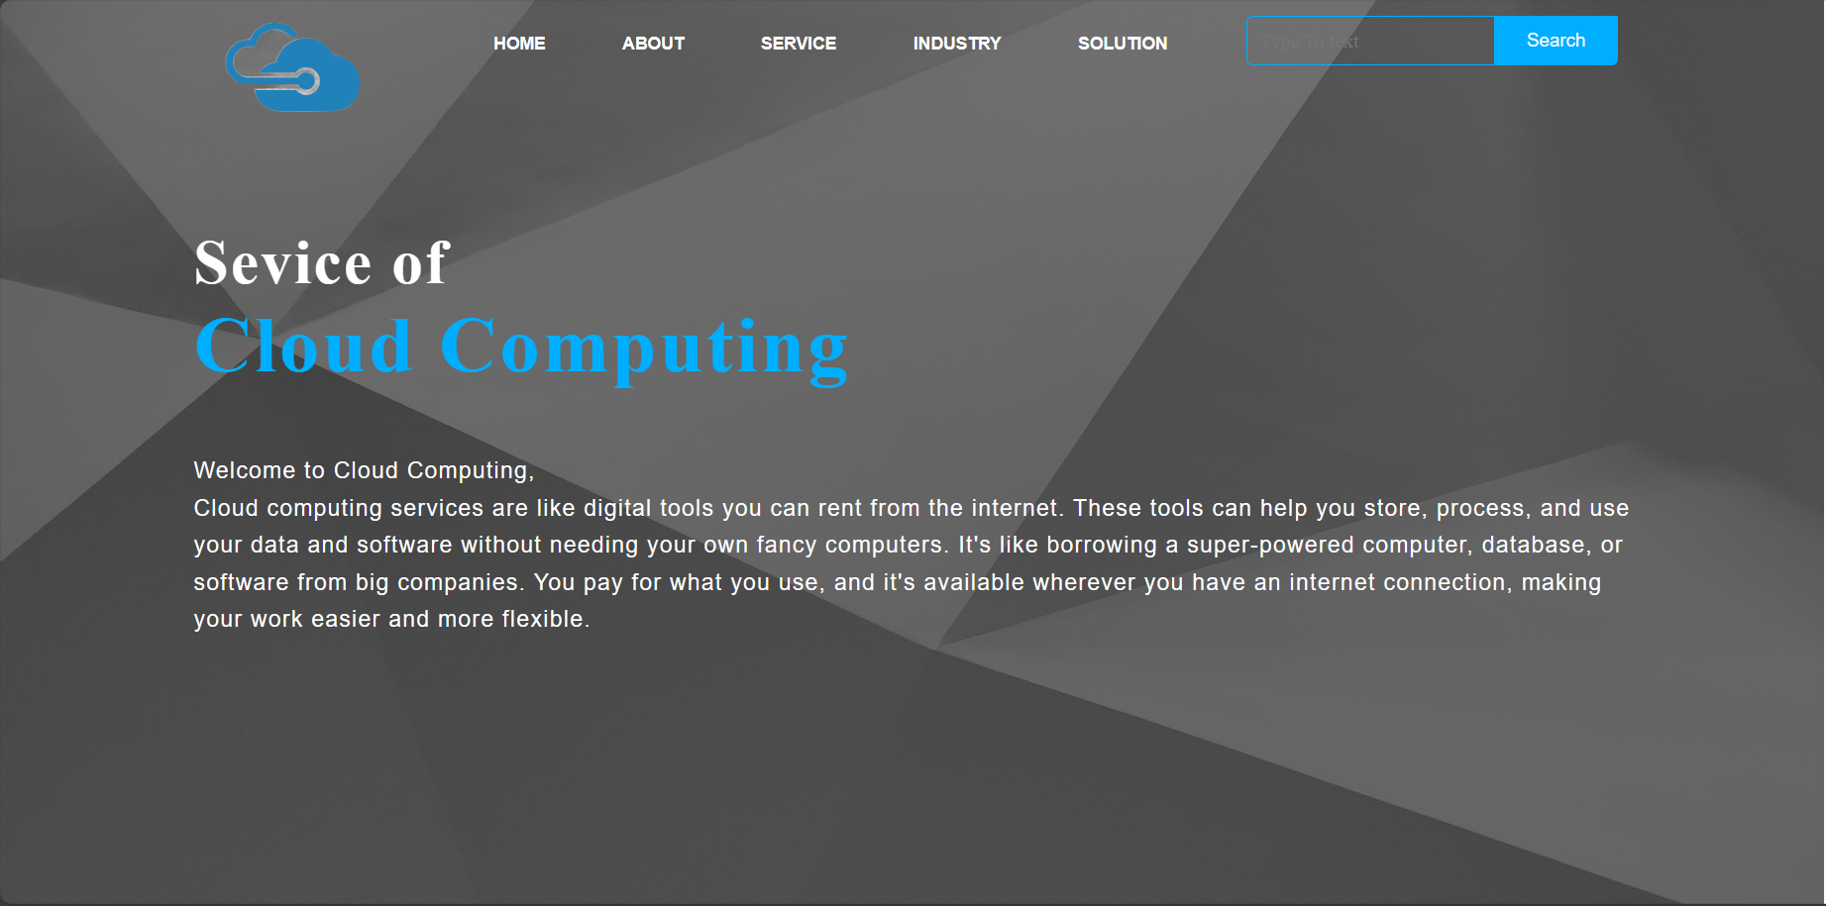

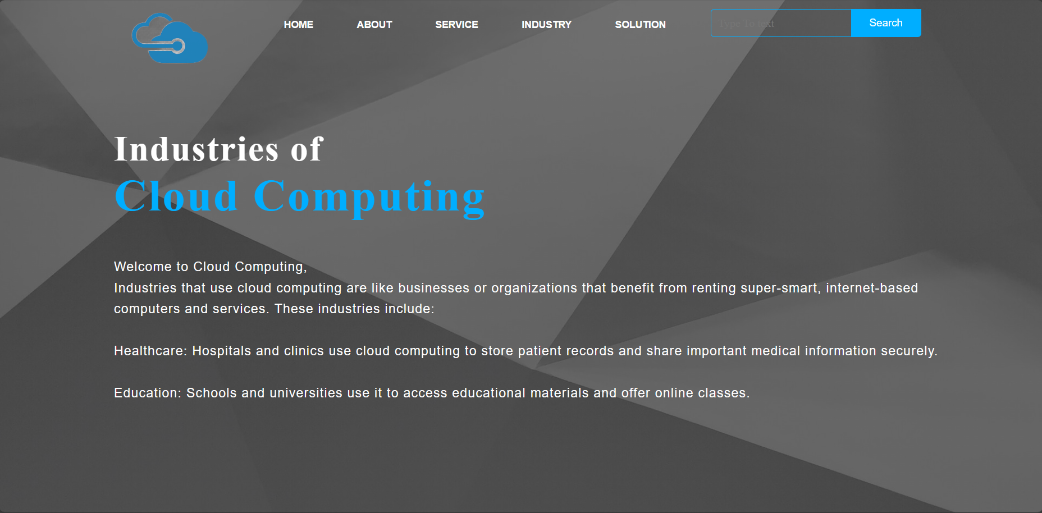

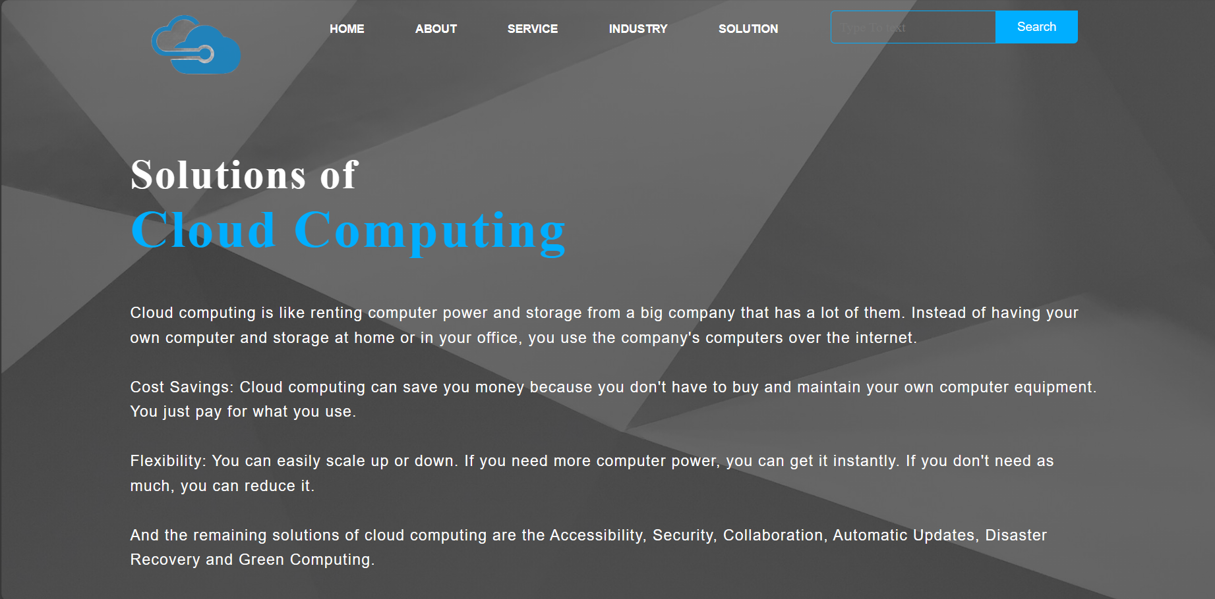

**User can view the output of the web page without server by clicking below link:**

**Conclusion:**

Our serverless website, designed for user authentication and content navigation, leverages cloud technology to provide a cost-effective, scalable, and secure solution. With a straightforward interface and efficient backend services, it offers a seamless user experience. Continuous monitoring and future enhancements will ensure its long-term success.